1.What are the benefits of using CSS?

**Ans.** The benefits of using CSS is that we can add style to a web page by dictating how it displayed on a browser and also it separate the content and style of the presentation and responsive design.

2.What are the disadvantages of CSS?

**Ans.** Disadvantages of CSS are Complex Layouts and Limited Layout control, File size and Performance impact, Overriding Styles etc.

3.What is the difference between CSS2 and CSS3?

**Ans.** CSS3 is more versatile stylesheet language than CSS2 because CSS3 offers new features that make it easier to create responsive, dynamic visually appealing web pages. It also includes features like flexbox, grid, animations and transitions.

4.Name a few CSS style components.

**Ans.** There are various style components of CSS.

1. Height
2. Width
3. Background-color
4. Display
5. Font-size
6. Justify-content

5.What do you understand by CSS opacity?

**Ans.** Opacity CSS sets the opacity of an elements. The opacity-level describes the transparency level that is 1 is not transparent at all, 0.5 is 50% see through and 0 is completely transparent.

6.How can the background color of an element be changed?

**Ans.** Background-color is the property which is used to change the background color of an element in webpage and it is only used inside the style tag in HTML.

7.How can image repetition of the backup be controlled?

**Ans.** This thing can be achieved by using the background-repeat property which helps us to control the repetition of the image both horizontally and vertically.

8.What is the use of the background-position property?

**Ans.** It is mainly used to set an image to a certain position from a starting position of a image which is relative to the positioning layer.

9.Which property controls the image scroll in the background?

**Ans.** The Background-attachment property is used to specify that image will scroll along with the rest of the elements on the page or the image will stay fixed to the page.

10.Why should background and color be used as separate properties?

**Ans.** By using separate properties we can get greater flexibility and specificity when styling elements and can easily target and modify the background and text color independently.

11.How to center block elements using CSS1?

**Ans.** There are 2 types of ways to center block elements.

1.By setting the margin-left and margin-right to auto and width to some value.

2.By using the align-items and justify-content properties.

12.How to maintain the CSS specifications?

**Ans.** World Wide Web Consortium can maintain the CSS specifications.

13.What are the ways to integrate CSS as a web page?

**Ans.** There are 3 ways to integrate CSS.

1.Internal CSS

2.External CSS

3.Inline CSS

14.What is embedded style sheet?

**Ans.** An embedded style sheet is declared within the head tag elements of an XHTML document.

15.What are the external style sheet?

**Ans.** External style sheet is separate CSS file which can be accessed by creating a link within the head section.

16.What are advantage and disadvantage of using external style sheet?

**Ans.** Advantages of using external style sheet are as follow:

1. Seperation of content and style.
2. Responsive Design.
3. Accessibility.
4. Global styling.
5. Animations and Effects.

Disadvantages of using external style sheet are as follow

1. Lack of Security.
2. Limited Layout Control.
3. Performance Impact.
4. Overriding Styles.
5. Maintenance Challenges.

17.What is meaning of CSS selector?

**Ans.** A CSS selector is a code that specifies which elements on a webpage should be styled and how they should be styled.

18.What are the media types allowed by CSS?

**Ans.** CSS allows media types such as “all, screen, print, speech, and handheld” to targeted for styling.

19.What is the rule set?

**Ans.** A rule set in CSS is a collection of CSS declarations that define the style and appearance of HTML elements. It consists of a selector and a declaration block.

20.Create image gallery using display grid with responsive.

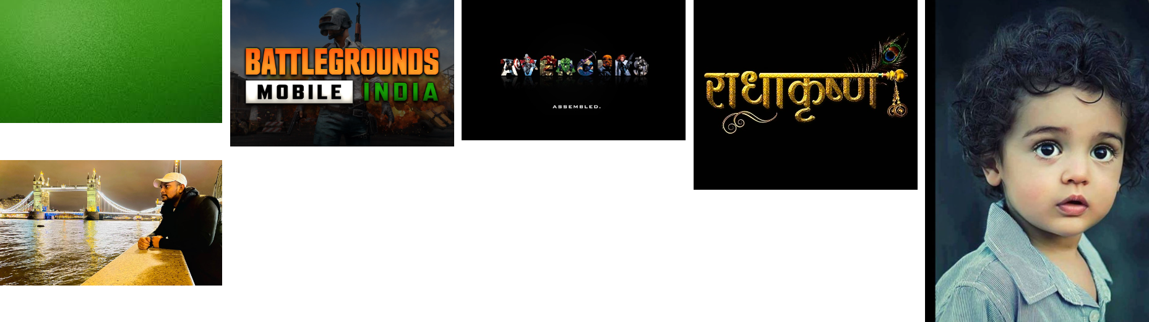

21.Create below example with the help of clip path.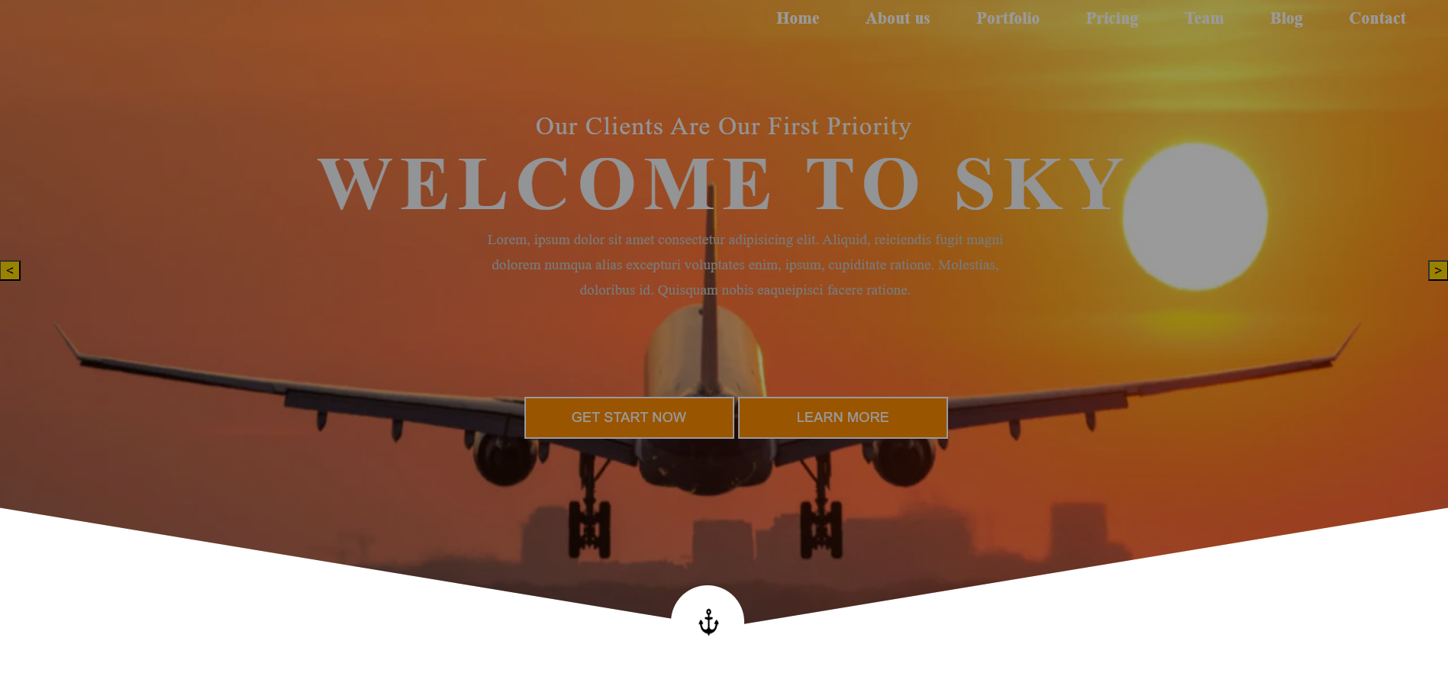 

22.Multiple Backgrounds one side bg-color other side contain image as bg.

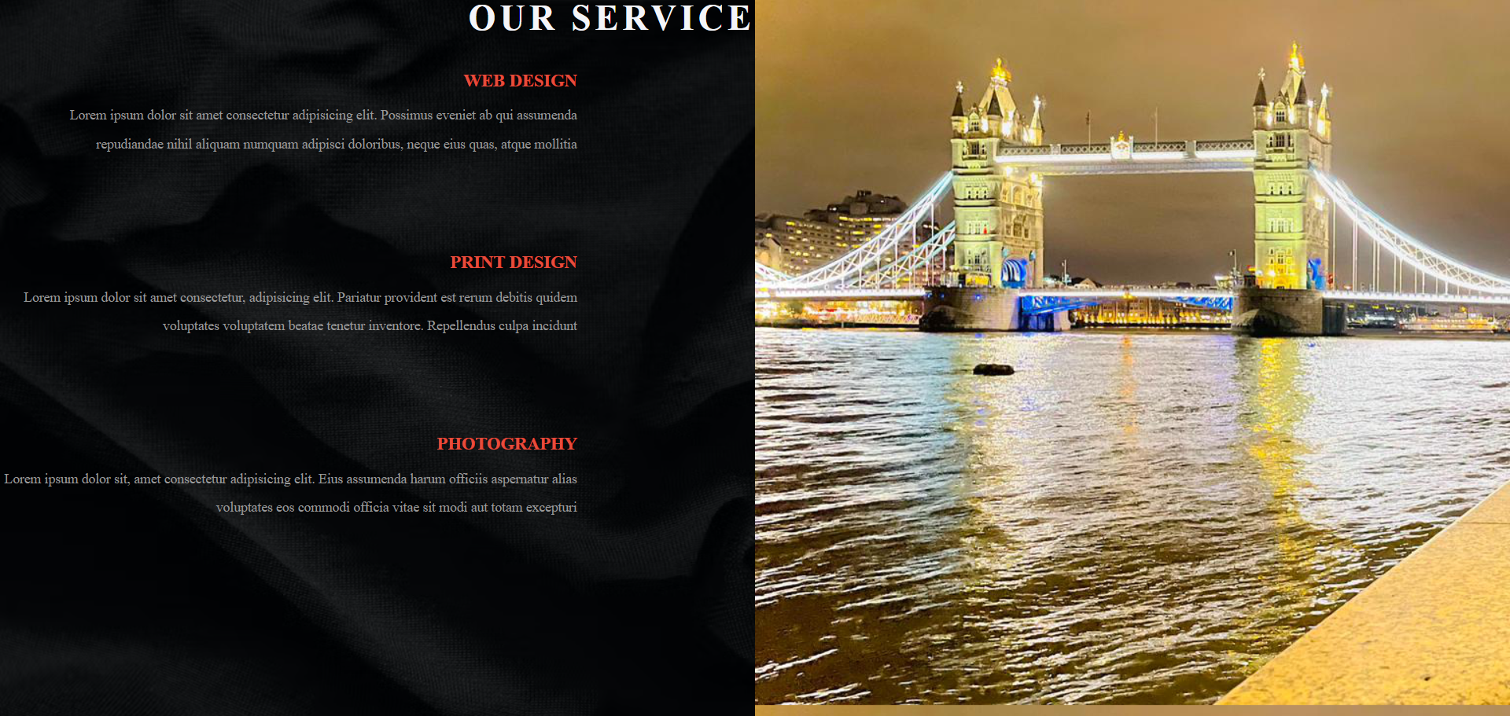

23.Create below example using CSS waves generator.

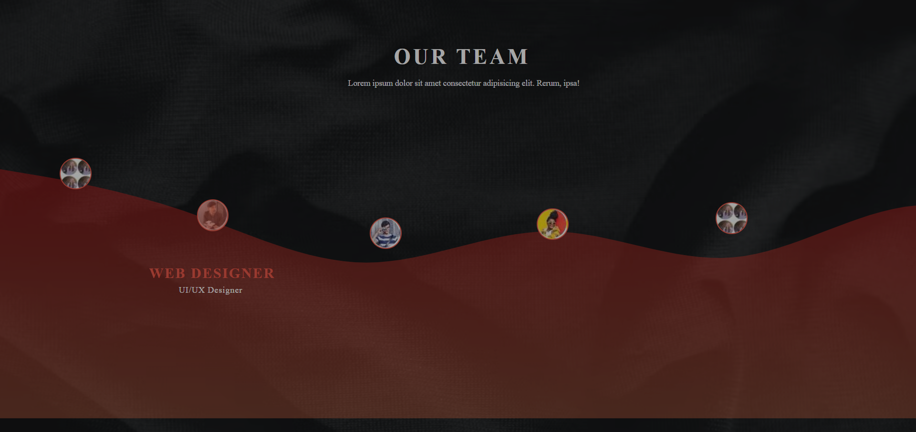

24.Create Layouts.

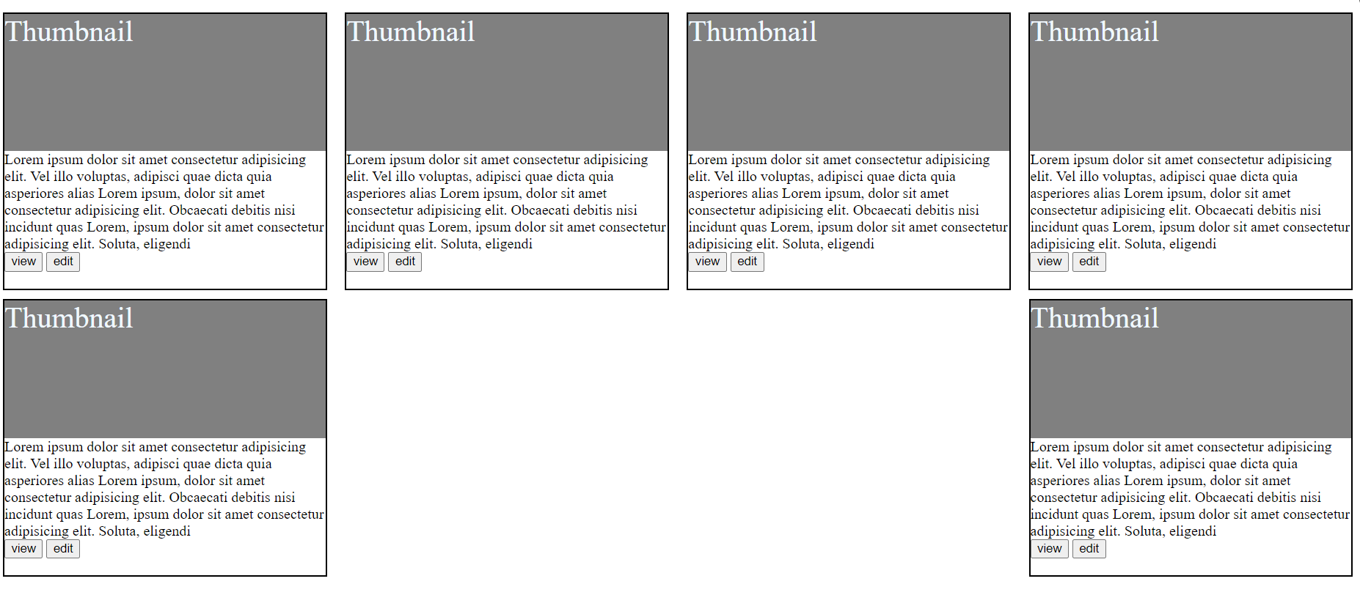

25.Create below example responsive media query.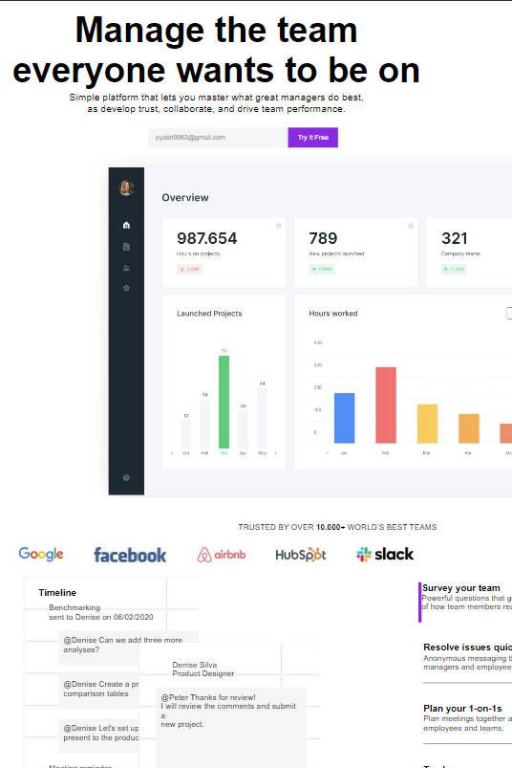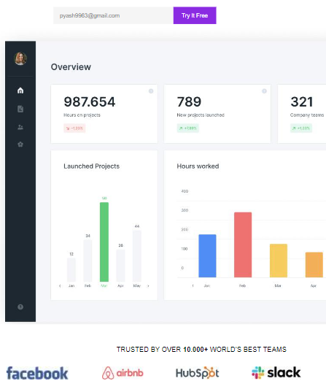

**Desktop**

**Mobile**